FORNAX™ ePlanCheck Rule
Rule Information
Rule ID | SSW 3.1.3.2 (b)
Rule Name | Main Drain-line - Inspection Chamber
Chapter | 3. Sanitary Works
Section | 3.1 Sanitary Drainage System
Handbook | Code of Practice on Sewerage and Sanitary Works  Addendum No. 2 – Nov 2004

Rule Description
3.1.3.2 Main Drain-line

(b) Inspection chambers shall be provided at all bends, junctions, at changes to the direction of flow or gradient
and at changes in pipe diameter or materials.

Rule Interpretation
- This rule checks for the provision of Inspection Chamber at the following points along the Main Drain-line :
  - At every bend or change in direction (Figure 01)
  - At every junction (Figure 02).
  - At every change in gradient (Figure 03)
  - At every change of pipe diameter (Figure 04) or
  - At every change of material (Figure 05).
- Couplings are allowed and no Inspection Chamber is needed, as long as there are no changes as stated above.
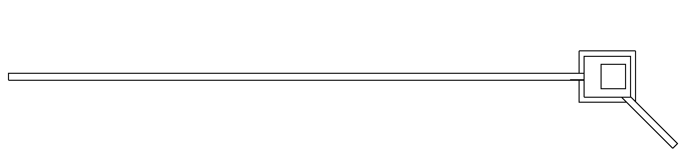
- Inspection Chambers are to be connected by a Main Drain-line.
INSPECTION
CHAMBER
MAIN DRAIN-LINE

PIPE BEND
PLAN

FIGURE 01
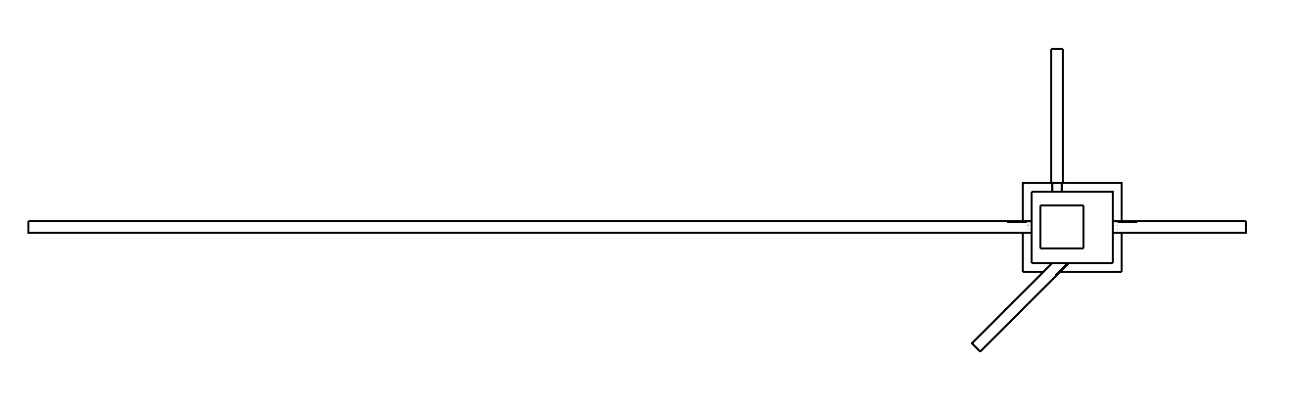

INSPECTION
CHAMBER

MAIN DRAIN-LINE

PIPE JUNCTION
PLAN
FIGURE 02

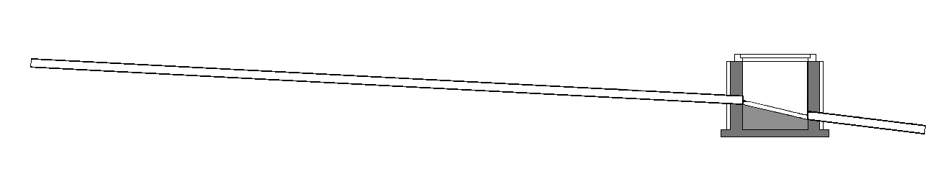
INSPECTION
CHAMBER
PIPE GRADIENT
1 : 4
PIPE GRADIENT
1 : 6

MAIN DRAIN-LINE
SECTION

FIGURE 03

INSPECTION
CHAMBER
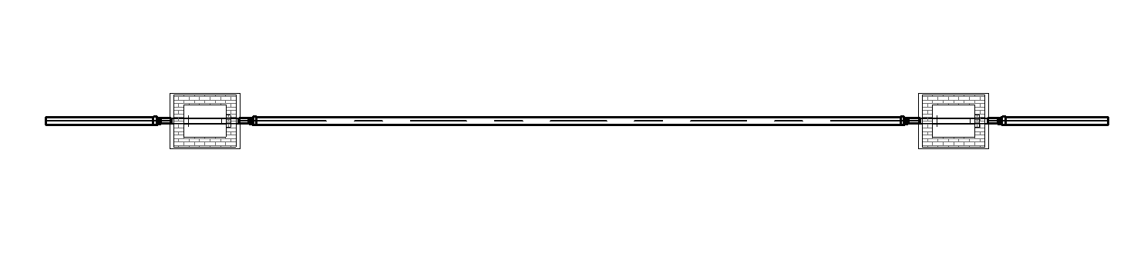
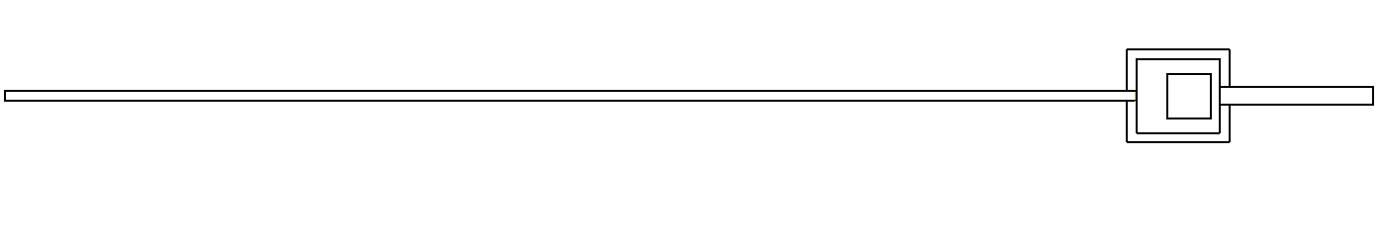
150MM Ø MAIN DRAIN-LINE
300MMØ MAIN
DRAIN-LINE
PLAN
FIGURE 04
PVC PIPE MAIN DRAIN-LINE
CONCRETE PIPE MAIN
DRAIN-LINE
INSPECTION
CHAMBER
PLAN
FIGURE 05
PIPE CHANGE IN DIAMETER
PIPE CHANGE IN MATERIAL

Rule Scenario

Scenario 01-Compliant
Requirement | Provision of inspection chamber for main drain-line pipe bends.
Conditions | Pipes should be connected to inspection chamber/s.
Description | Provision of inspection chamber to a Main Drain-line where a change in lateral direction or a ¼ bend (45 degrees) occurs.
INSPECTION CHAMBER
MAIN DRAIN-LINE
MAIN DRAIN-LINE BEND TO THE RIGHT

PLAN
FIGURE SCENARIO 01
Scenario 01-Non-compliant
Requirement | Provision of inspection chamber for main drain-line pipe bends.
Conditions | Pipes should be connected to inspection chamber/s.
Description | 1/8 bend occurs along a Main Drain-line but no inspection chamber is provided.
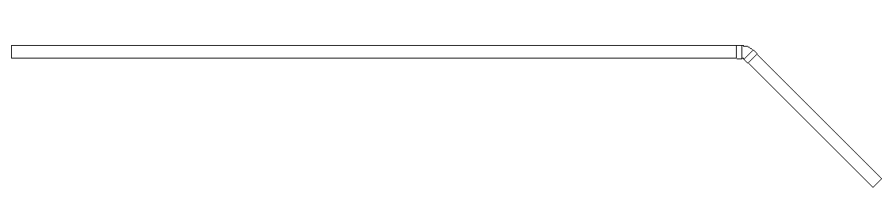
MAIN DRAIN-LINE
BEND

MAIN DRAIN-LINE BEND TO THE RIGHT

PLAN
FIGURE SCENARIO 01

Scenario 02-Compliant
Requirement | Provision of inspection chamber for main drain-line pipe junctions.
Conditions | Pipes should be connected to inspection chamber/s.
Description | Three main drain-line pipes merged in a same spot where inspection chamber is provided.
PLAN
FIGURE SCENARIO 02
MAIN DRAIN-LINE
INSPECTION CHAMBER
PERPENDICULARLY MERGING DRAIN LINE
DIAGONALLY MERGING DRAIN LINE

Scenario 02-Non-compliant
Requirement | Provision of inspection chamber for main drain-line pipe junctions.
Conditions | Pipes should be connected to inspection chamber/s.
Description | Three main drain-line pipes merged in approximately same spot but no inspection chamber is provided at the connections.
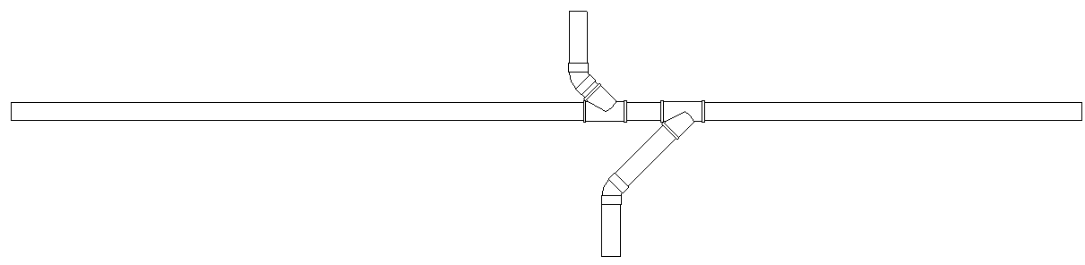
PERPENDICULARLY MERGING DRAIN LINE

MAIN DRAIN-LINE
MAIN DRAIN-LINE

DIAGONALLY MERGING DRAIN LINE
PLAN
FIGURE SCENARIO 02

Scenario 03-Compliant
Requirement | Provision of inspection chamber for main drain-line pipe gradients.
Conditions | Pipes should be connected to inspection chamber/s.
Description | Two main drain-line pipes with different gradient connected inside to an inspection chamber.
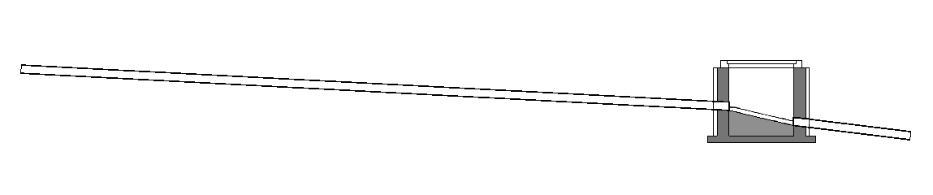
MAIN DRAIN-LINE
MAIN
DRAIN-LINE

SECTION
INSPECTION CHAMBER

FIGURE SCENARIO 03

Scenario 03-Non-compliant
Requirement | Provision of inspection chamber for main drain-line pipe gradients.
Conditions | Pipes should be connected to inspection chamber/s.
Description | Two main drain-line pipes with different gradient connected by a 1/8 bend elbow where inspection chamber is not provided at the connection.
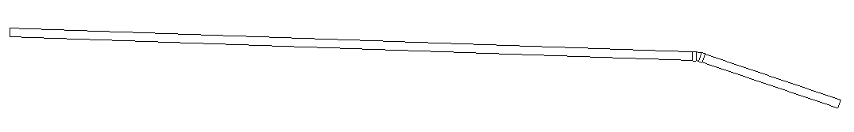
SECTION
FIGURE SCENARIO 03
MAIN DRAIN-LINE
MAIN DRAIN-LINE
BEND

Scenario 04-Compliant
Requirement | Provision of inspection chamber for main drain-line pipe diameters.
Conditions | Pipes should be connected to inspection chamber/s.
Description | Two main drain-line pipes with different diameters are connected inside where an Inspection Chamber is provided at the connection.
INSPECTION CHAMBER
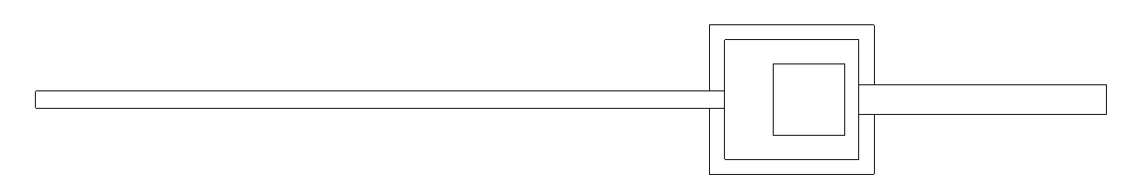
MAIN DRAIN-LINE = 150mm

MAIN DRAIN-LINE = 3000mm
PLAN
FIGURE SCENARIO 04

Scenario 04-Non-compliant
Requirement | Provision of inspection chamber for main drain-line pipe diameters.
Conditions | Pipes should be connected to inspection chamber/s.
Description | Two main drain-line pipes with different diameters are connected by a Pipe Reducer where inspection chamber is not provided.
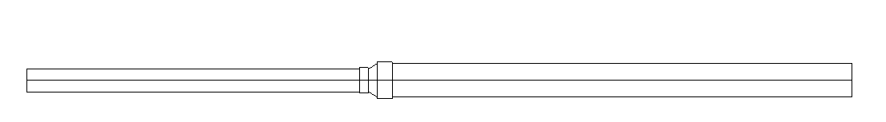
PIPE REDUCER
MAIN DRAIN-LINE = 300mm
MAIN DRAIN-LINE = 150mm

PLAN

FIGURE SCENARIO 04

Scenario 05-Compliant
Requirement | Provision of inspection chamber for main drain-line pipe materials.
Conditions | Pipes should be connected to inspection chamber/s.
Description | Two main drain-line pipes with different materials are connected inside where an Inspection Chamber is provided in the connection.
PLAN
FIGURE SCENARIO 05
PVC MAIN DRAIN-LINE
INSPECTION CHAMBER
CONCRETE PIPE
MAIN DRAIN-LINE

Scenario 05-Non-compliant
Requirement | Provision of inspection chamber for main drain-line pipe materials.
Conditions | Pipes should be connected to inspection chamber/s.
Description | Two main drain-line pipes with different materials are connected by a concrete grout where inspection chamber is not provided.
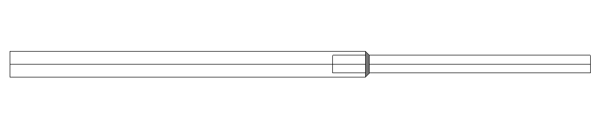
CONCRETE PIPE
MAIN DRAIN-LINE
PVC PIPE MAIN DRAIN-LINE

CONCRETE GROUT CAULKING

PLAN

FIGURE SCENARIO 04

Model PreCheck

Required Elements | Required Attributes
PipeSegment | IfcDescription contains “Main Drain Line”

Rule Parameters

System Type
Cold Water
Hot Water
 | Sanitary | 
 | Sewerage
Vent

Element Type 1
State | Type | Property | Operator | Value
Include | PipeSegment | IfcDescription | Contains | Main Drain Line
Exclude |  | Any | Match | N.A.
 |  | Name | N.A. | <User defined>

Element Type 1 Condition
* Provide Inspection Chamber at every Bend, Junction, Change in gradient, Change pipe diameter
and Change in material of Element Type 1.

* Should be connected to Inspection Chamber

Result Messages
- 3.1.3.2 (b) Main Drain-line - Inspection Chamber
  - Non-compliant (TotalResultNumeric)
    - BuildingStorey (TotalResultPerFloorNumeric)
      - ElementType1Name has no Inspector Chamber at ElementCondition.
  - Compliant (TotalResultNumeric)
    - BuildingStorey (TotalResultPerFloorNumeric)
      - ElementCondition; Inspection ChamberNumericName; ElementType1Name

Sample Result Messages
- 3.1.3.2 (b) Main Drain-line - Inspection Chamber
  - Non-compliant (5)
    - Level 1 (5)
      - Main Drain-line 1.01 has no Inspection Chamber at bend.
      - Main Drain-line 1.02 has no Inspection Chamber at junction.
      - Main Drain-line 1.03 has no Inspection Chamber at change in gradient.
      - Main Drain-line 1.04 has no Inspection Chamber at change in pipe diameter.
      - Main Drain-line 1.05 has no Inspection Chamber at change in material.
  - Compliant (2)
    - Level 1 (2)
      - Bend; Inspection Chamber 1.01; PipeSegment: PVC; PipeSegment: PVC
      - Junction; Inspection Chamber 1.02; PipeSegment: PVC; PipeSegment: PVC; PipeSegment: PVC
      - Change in gradient; Inspection Chamber 1.03; PipeSegment: PVC
      - Change in pipe diameter; Inspection Chamber 1.04; PipeSegment: PVC; PipeSegment: PVC
      - Change in material; Inspection Chamber 1.05; PipeSegment: PVC ; PipeSegment: CONCRETE
- Attention (1)
    - Level 1 (1)
      - No inspection chamber to check.
    - Level 1 (1)
      - No main drain-line to check.
    - Level 1 (1)
      - No adjacent main drain-line to check.

Sample Result Model Views
- 3.1.3.2 (b) Main Drain-line - Inspection Chamber
- Non-compliant
- Plan view.
- Highlight checked element/space.
- All other elements are translucent except checked element/space.
- Compliant
- Plan View.
- Highlight checked element/space.
- All other elements are translucent except checked element space.

Testing Scenarios
- Scenario 01-Compliant
- Site Level
- Provision of inspection chamber to a Main Drain-line where a change in lateral direction or a ¼ bend (45 degrees) occurs.

- Scenario 01-Non-compliant
- Site Level
- 1/8 bend occurs along a Main Drain-line but no inspection chamber is provided.

- Scenario 02-Compliant
- Site Level
- Three main drain-line pipes merged in approximately same spot but no inspection chamber is provided at the connections.

- Scenario 02-Non-compliant
- Site Level
- Three main drain-line pipes merged in approximately same spot but no inspection chamber is provided at the connections.

- Scenario 03-Compliant
- Site Level
- Two main drain-line pipes with different gradient connected inside to an inspection chamber.

- Scenario 03-Non-compliant
- Site Level
- Two main drain-line pipes with different gradient connected by a 1/8 bend elbow where an
inspection chamber is not provided but at the connection.

- Scenario 04-Compliant
- Site Level
- Two main drain-line pipes with different diameters are connected inside where an Inspection Chamber is provided at the connection.

- Scenario 04-Non-compliant
- Site Level
- Two main drain-line pipes with different diameters are connected by a Pipe Reducer where inspection chamber is not provided.

- Scenario 05-Compliant
- Site Level
- Two main drain-line pipes with different materials are connected inside where an Inspection Chamber is provided in the connection.

- Scenario 05-Non-compliant
- Site Level
- Two main drain-line pipes with different materials are connected by a concrete grout where inspection chamber is not provided.

Model:
SSW 3132 b-01-C.ifc
SSW 3132 b-01-NC.ifc
SSW 3132 b-02-C.ifc
SSW 3132 b-02-NC.ifc
SSW 3132 b-03-C.ifc
SSW 3132 b-03-NC.ifc
SSW 3132 b-04-C.ifc
SSW 3132 b-04-NC.ifc
SSW 3132 b-05-C.ifc
SSW 3132 b-05-NC.ifc

Links:
\\revit02\PROJECT\SG-EPlan Checking\01-WIP\ePC Development\PUB\RuleSpecification_RegRule\SSW
3.1.3.2. b\Revit Models

Modelling Guideline
- Specify IfcDescription containing “Main Drain Line” for relevant PipeSegment.
- Specify IfcName containing “Inspection Chamber’ for relevant DistributionChamberElement.

Specification Log
RA | Alvin Q. Estocapio
Last edit date | 27 July 2018
ePC version
Updates | - V1

Specification Log
RA | Alvin Q. Estocapio
Last edit date | 13 August 2018
ePC version
Updates | - V2-Update rule interpretation and scenarios based on latest PUB comments

